Using JBuilder with IBM WebSphere servers
This chapter explains how set up and use IBM WebSphere servers with JBuilder. JBuilder supports WebSphere Application Server 4.0.6 Single Server, WebSphere Application Server 4.0.6 Advanced Edition, and WebSphere Application Server 5.0.2.

Configuring JBuilder for WebSphere servers
To configure JBuilder settings to target WebSphere servers,
- Choose Tools|Configure Servers.
The Configure Servers dialog box appears.
- Select the WebSphere server you want to configure by clicking it in the pane on the left.
The right side of the dialog box lists the default settings for the selected server. The General page has fields that all servers have in common, while the Custom page has fields that are specific to the selected server. In some cases, modifying a Custom setting will update a setting on the General page.
- Check the Enable Server check box at the top of the dialog box.
Checking this option enables the fields for the selected application server. You won't be able to edit any fields until it is checked. The Enable Server check box also determines whether this server will appear in the list of servers when you select a server for your project using the Servers page of the Project|Project Properties dialog box.
JBuilder provides default settings for the selected server. If JBuilder's default settings are not appropriate, edit any of the settings as needed. Some servers require you to enter settings in addition to the defaults. Clicking the OK button in this dialog box when not all required values are set or selecting another server while the current one is enabled displays a message dialog box that informs you about the missing settings.
- If you want to change any of the settings, click the ellipsis (…) button next to the field and make your changes. If you installed WebSphere into [drive]:/Program Files/WebSphere, the default Home Directory is [drive]:/Program Files/WebSphere/AppServer. Otherwise, the Home Directory becomes whichever directory you specify.
- Click the Custom tab to view fields unique to the server. Change or fill in these fields:
For WebSphere Application Server 4.0.6:
  - IBM JDK Installation Directory: Where the IBM installation of the JDK is installed. JBuilder uses this field to locate the proper version of the JDK the server requires. This field is set when you specify the Home Directory, so it should be the java directory of the Home Directory; for example, the directory would be [drive]:/Program Files/WebSphere/AppServer/java if [drive]:/Program Files/WebSphere/AppServer is your Home Directory.
  - DB2 Installation Directory: The directory in which DB2 is installed on your system. Usually this is in [drive]:/SQLLIB.
  - Add An Administrator's Console Item to The Tools Menu: Checking this check box adds the WebSphere Admin Console item to JBuilder's Tools menu so you have quick access to it from the JBuilder IDE.
  - Add an Application Assembly Tool Item to The Tools Menu: Checking this check box adds the WebSphere Application Assembly item to JBuilder's Tools menu so you have quick access to this tool from the JBuilder IDE.
For WebSphere Application 5.0.2:
  - JDK Installation Directory: Where the IBM installation of the JDK is installed. This field is set when you specify the Home Directory, so it should be the java directory of the Home Directory; for example, [drive]:/Program Files/WebSphere/AppServer/java.
  - Embedded Message Path: The directory where WebSphere's messaging software is located. This field is set by default and is usually in the Ibm/WebSphere MQ directory. So, if you installed WebSphere into [drive]:/Program Files/WebSphere, the Embedded Messaging Path would be [drive]:/Program Files/Ibm/WebSphere MQ. You can, however, specify any path directly that contains the messaging software.
  - Cell Name: The cell name is set by default. It is read in from your local server configuration. You can edit this field, but you will seldom need to do so. For more information about cells, see your WebSphere documentation.
  - Node Name: The node name is set be default. It is read in from your local server configuration. You can edit this field, but you will seldom need to do so. For more information about nodes, see your WebSphere documentation.
  - Server Name: The server name which you are configuring. It is read in from your local server configuration. JBuilder suggests a default name, which you can change to meet your needs.
  - Add An Administrative Console Item To The Tools Menu: Checking this check box adds the WebSphere Admin Console item to JBuilder's Tools menu so you have quick access to it from the JBuilder IDE. You must also fill in the next field, Web Browser Path, to have the menu item added.
  - Web Browser Path: Specify the path and file name of the web browser of your choice. For example, you might specify c:/Program Files/Internet Explorer/iexplore.exe if you want to use Microsoft's Internet Explorer.
  - Add An Application Assembly Item To The Tools Menu: Checking this check box adds the WebSphere Application Assembly item to JBuilder's Tools menu so you have quick access to this tool from the JBuilder IDE.
  - Add An Administrative Scripting Item To The Tools Menu: Checking this check box adds the WebSphere Administrative Scripting item to JBuilder's Tools menu so you have quick access to this tool from the JBuilder IDE.
  - This step is optional. Click the CMP Mapping button to display the CMP Mapping page. Use this page to view and possibly change the container-managed persistence (CMP) mappings JBuilder uses. By examining the tables on this page, you can see the mappings JBuilder is using. Usually you will not need to change any of these mappings, especially if you are using the more common database drivers. You can, however, edit these mappings if you are using other drivers, want to do your own type mappings, and so on. For more information about editing mappings and aliases, click the Help button.
- Choose OK to close the dialog box and configure JBuilder.
When you configure JBuilder to target a WebSphere server, required libraries are created for you. To see a list of the WebSphere libraries, see "The created libraries."

Selecting a server
If you are working with more than one version of WebSphere Application Server and have configured JBuilder for all versions, you must select which version you want to use for your current project. Choose Project|Project Properties and choose Server. See "Selecting a server" in the "Configuring the target application server settings" for more information.

Working in JBuilder with WebSphere 4.0

Generating WebSphere deployment descriptors
When you are using the Enterprise JavaBean 1.x wizard or the EJB 1.x Entity Modeler to create entity beans that target WebSphere 4.0 Advanced Edition, the wizards do not generate the Map.mapxmi and Schema.dbxmi deployment descriptors. When you build your bean, EjbDeploy, which is called during the build process, will generate them for you. You can then modify the mapping and run Make again to keep the mapping in the JAR.
If you've used the Entity Modeler to create your entity beans and the field names in your bean don't map directly to columns in the database, you can choose to have JBuilder create WebSphere CMP deployment descriptors that override the default EjbDeploy behavior:
- Right-click the EJB module node in the project pane when WebSphere 4.0 Advanced Edition is your selected server.
- Choose Properties on the context menu.
- Click the WebSphere AE 4.0 tab.
- Check the Generate CMP Descriptors check box.
- Make your changes.
The list of Data Mapping Files contains the default mapping files that are used to map Java primitive types to database types. You can modify, add, and remove mapping files. The Database Type Substitution In Generated Descriptors list displays the substitutions JBuilder makes if the Java primitive types can't be directly mapped to a type in the database. You can modify this list. For example, you might want another Java type to be substituted for a particular original type in a specified database. Or you can add additional substitutions to the list.
- Click OK.
When you compile your bean, the two deployment descriptors (Map.mapxmi and Schema.dbxmi are generated for entity beans with container-managed persistence for the WebSphere 4.0 Advanced Edition only. If you are using one edition of WebSphere 4.0 and change your target server to the other version, you must recompile your project to ensure JBuilder generates the correct deployment descriptors for you.
If the database schema name used is different from the username, manually modify the Schema.dbxmi file as follows:
- Make the project to generate the CMP descriptors.
- Double-click the EJB module node in the project pane to open the EJB module viewer.
- Click the source view for Schema.dbxmi.
- Add the following line above the last line of the source:
<RDBSchema:RDBSchema xmi:id="RDBSchema_1" name="<your_schema_name>" database="<database_id>" tables="<table_id>"/>
- Rebuild the project to incorporate the change.

Starting the server
To prepare to start the server from within JBuilder, create a server runtime configuration. Follow these steps:
- Choose Run|Configurations.
- In the dialog box that appears, click the New button.
- Select Server from the Type drop-down list.
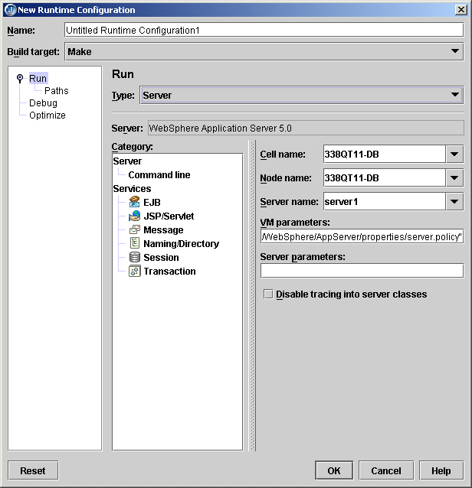
- In the Name field, enter a name, such as Server or something that will identify the run configuration.
- Fill in the VM Parameters and Server Parameters needed to run the server. If you've selected a target application server as described in "Selecting a server," default values are already in place.
- Click OK.
To start the server, click the down-arrow next to the Run Project icon () and select the server run configuration you just created.
By default in WebSphere 5.0, the stdout and stderr streams are redirected to log files at application server startup. To view the output in JBuilder when you start the server in JBuilder:
- Start the server.
- Start the Administrative Console from the JBuilder Tools menu.
- Choose Servers|Application Servers|<server_name>|Process Definition|ProcessLogs.
- On the Configuration page, set the Stdout File Name and the Stderr File Name to Console.

Deploying

Using the DD Editor
The DD Editor has several WebSphere-specific pages for information that applies only to WebSphere servers. For information about using the DD Editor to edit J2EE modules, see "Editing J2EE deployment descriptors." Whenever a WebSphere-specific page is displayed in the DD Editor, you can press F1 for help on that particular page. You'll also find it convenient to have a copy of your server's documentation handy to look up the type of information your server requires in the deployment descriptors.
To prepare to deploy a deployable module, follow the steps outlined for your version of WebSphere:

WebSphere Application Server 5.0

Remote deploying
WebSphere Application Server 5.0 supports remote deployment using the Deployment Manager version of the application server. The Deployment Manager must be configured to manage the remote server instance. Please refer to your server documentation for more information.
Once you have configured your Deployment Manager to manage the remote server instance, you can deploy to the remote server instance in JBuilder if you follow these steps:
- Right-click the archive node you want to deploy in JBuilder's project pane and choose Properties.
- Select Deployment in the tree to display the Deployment page and make sure the General tab is selected.
- Set the Cell Name to the Deployment Manager's cell name.
- Set the Node Name to the remote server node name.
- Set Server Name to the remote server name.
- Click the Connection tab.
- Set the Connection Type field to SOAP or RMI.
- Set the Host field to the host name where the Deployment Manager is running.
- Set the Port field to the port number of the Deployment Manager.
- Set the User Name and Password fields if they are required; for example, if security is enabled.

Deploying locally
To deploy locally to a server which is not running,
- Right-click the node you want to deploy in JBuilder's project pane and choose Properties.
- Select Deployment in the tree and click the Connection tab.
- Set the Connection Type to NONE.
If the connection type is set to NONE, deployment actions performed while the server is running won't start or stop the deployed module.

WebSphere Server 4.0
If you are using WebSphere 4.0 Advanced Edition, you must create an EAR group that contains your beans. You then deploy the EAR group. For more information about creating EAR groups, see "Creating an EAR file."
Tools|Server Deployment displays a WebSphere Deploy Settings dialog box. Configure your deployment settings with this dialog box. JBuilder passes the settings you specify on to the WebSphere deployment tool. The deployment tool for WebSphere 4.0 differs depending on the version of the server you are using. For the Single Server, WebSphere's deployment tool is SEAppInstaller. For the Advanced Edition, the deployment tool is XmlConfig. Therefore, the appearance of the Deploy Settings dialog box will vary between these two WebSphere Server 4.0 editions.
If your target application server is WebSphere 4.0 Advanced Edition and you want an XML file to be generated as input to the WebSphere XMLConfig utility, check the Generate XML check box. If this option isn't checked, the file won't be created. If you make your own modifications to the generated XML file (named deploy_<selectednode>.xml and appearing under the EJB module node or EAR group), uncheck this option to be sure you don't lose your changes. If you use the Deployment Options on the context menu (right-click the EJB module and choose Deployment Options <jar name>.jar to see the deployment commands), the generated XML file is deploy.xml. It appears under the project node.

Remote deploying
Follow these steps to use the WebSphere Deploy Settings dialog box to deploy to a remote server:
- Choose Tools|Server Deployment.
- Select the Deploy action.
- Specify these options in the Options field:

- -nameServiceHost<host name> -nameServicePort<port number>

- Set the Primary Node and Server Name to match your server configuration.
- Click OK.
You can also deploy a module to a remote server from JBuilder's project pane:
- Right-click the module you wish to deploy.
- Select Properties.
- Select Deployment in the tree to display the Deployment page.
- Specify these options in the Options field:

- -nameServiceHost<host name> -nameServicePort<port number>

- Set the Primary Node and Server Name to match your server configuration.
- Right-click the module in the project pane and choose Deploy Options|Deploy.

Deploying locally
These are the deploy options you'll find on the Deploy Options context menu:
- Deploy - Deploys a JAR to the currently running container of the project application server. If the Build Target option is Make for the current runtime configuration (Choose Run|Configurations, select the current runtime configuration, and click Edit then click Server and select Deployment in the tree of services to see the Build Target), this option will "make" the JAR's contents before deploying it to the container.
- Redeploy - Deploys a JAR again to the currently running container. If the Build Target option is Make for the current runtime configuration (Choose Run|Configurations, select the current runtime configuration, and click Edit then click Server and select Deployment in the tree of services to see the Build Target), this option will "make" the JAR's contents before redeploying it to the container.
- Undeploy - Undeploys an already deployed JAR in the running container.
- List Deployments - Lists all JARs deployed in the running container.
- Stop Container - Stops the container. This option appears for WebSphere 4.0 Advanced Edition only. When a deployed EJB changes, the container must be stopped and then restarted for the changes to register.
- Start Container - Starts the container. This option appears for WebSphere 4.0 Advanced Edition only.

Enabling remote debugging
The steps to enable remote debugging of a bean running on a WebSphere server vary depending on which version of WebSphere you are using.
Note: You won't be able to debug JSPs in a remote debug session.

WebSphere Application Server 5.0
Follow these steps to enable remote debugging for WebSphere Application Server 5.0:
- Launch the server with the -script option:
- WEBSPHERE_HOME/bin/startserver -script
This command should write a script called start_<server name> in the WEBSPHERE_HOME/bin directory.
- Edit the launch script and add the following remote debug parameters to the java command line:

- -Xdebug -Xnoagent -Djava.compiler=NONE
- -Xrunjdwp:transport=dt_socket,server=y,address=3999,suspend=n
- Launch the server using the script.
- In JBuilder, choose Project|Project Properties. If you have not yet created a server run configuration, choose New and create a new configuration of type Server. If you already have a server run configuration, choose Edit.
- Select Debug|Remote in the tree and check the Enable Remote Debugging and Attach options and click OK.
Click the down arrow next to the Debug Project icon () on the JBuilder toolbar and select the debug run configuration you just created or edited. You will now be able to set breakpoints in Java code, such as in EJBs, servlets, and so on.

WebSphere Single Server 4.0
If you are using WebSphere Single Server 4.0, follow these steps to enable remote debugging:
- Launch the server with the -script option:
- WEBSPHERE_HOME/bin/startserver -script
This command should write a script called launch in the WEBSPHERE_HOME/bin directory.
- Edit the launch script and add the following remote debug parameters to the java command line:

- -Xdebug -Xnoagent -Djava.compiler=NONE
- -Xrunjdwp:transport=dt_socket,server=y,address=5000,suspend=n
- Launch the server using the script.
- In JBuilder, choose Project|Project Properties. If you have not yet created a server run configuration, choose New and create a new configuration of type Server. If you already have a server run configuration, choose Edit.
- Select Debug|Remote in the tree.
- Check the Enable Remote Debugging and Attach options and click OK.
Click the down arrow next to the Debug Project icon () on the JBuilder toolbar and select the debug run configuration you just created or edited. You will now be able to set breakpoints in an Java code, such as EJBs, servlets, and so on.

WebSphere Server Advanced Edition 4.0
WebSphere Server Advanced Edition 4.0 launches another Java virtual machine for debugging, so you must follow instructions so you can debug your enterprise beans:
- Start the WebSphere Server 4.0.
- Start the WebSphere Server 4.0 console application (which you'll find at <ws4_ae home>\bin\adminclient.bat if you're running on Windows.)
- When the console application appears, expand the tree on the left until you see the Application servers node. Select this node.
- In the panel on the right side of the console, click the JVM Settings tab. Click the Advanced Settings button. (You might need to scroll the panel to see this button.)
- In the dialog box that appears, enter the following VM options:

- -Xdebug -Xnoagent -Djava.compiler=NONE
- -Xrunjdwp:transport=dt_socket,server=y,address=5000,suspend=n
- If you start the server outside of JBuilder, choose Run|Configurations and click the New button in the dialog box that appears. In the Configuration Name field, specify a name for the new run configuration server for debugging on your application server.
- Select Debug|Remote and make these changes on the Debug page:
  - Check the Enable Remote Debugging check box.
  - Select the Attach option.
  - In the Port Number field, enter the port number you noted during the server startup process.
  - Click OK twice to close all dialog boxes.
- Click the down arrow next to the Debug Project icon () on the JBuilder toolbar and select the debug run configuration you just created or edited.
You will be attaching to the application server process. Now you can deploy your or web applications and you'll be able to stop at breakpoints you set in the bean, JSPs, or servlets.
To start the server in debug mode within JBuilder, follow these steps:
- Choose Run|Configurations.
- Select the Command node and enter the remote debug port number in the Debug Transport Address field.
Now clicking the debug toolbar button launches the server in debug mode and attaches to it, all in one session.

Container-managed persistence (CMP) 1.1 and 2.0 in WebSphere 5.0
You can set the schema name and database vendor type as properties on EJB module nodes:
- Right-click the EJB module and choose Properties.
- Select Build|WebSphere 5.0 in the tree.
- Enter your schema and database vendor information in this dialog box:
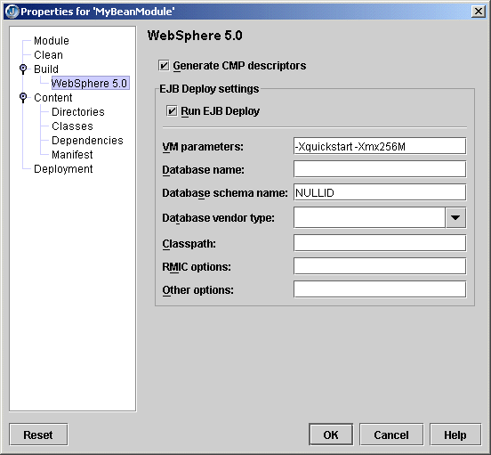
- Click OK.
To change the default CMP mapping behavior such as the Java to database type mappings,
- Choose Tools|Configure Servers.
- Select WebSphere Application Server 5.0 in the list of application servers.
- Click the Custom button.
- Click the CMP Mapping button.
- Make your changes in the CMP Mapping Settings dialog box that appears:
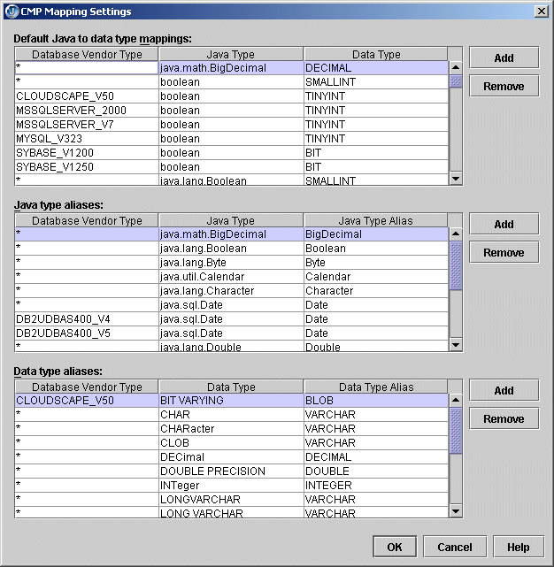
- Click OK.
These are your options:
- Default Java To Data Type Mappings: This list is used if JBuilder is unable to resolve the database schema type for a CMP field. This could happen if the JDBC driver fails to report a type for a database column or if the corresponding column (as defined in the CMP field mapping) is missing.
- Java Type Aliases: This list is used to translate between actual Java types in the bean and types defined in IBM database type mapping files.
- Data Type Aliases: This list is used to translate between database vendor types (as reported by the JDBC driver) and types defined IBM database type mapping files.

